Deploy The New UV machine software

Contents

Backup the current program 2

Create Machine Name 2

Troubleshooting 2

Verify Machine Name Created 2

Troubleshooting 2

Backup the program 3

Deploy the New Program 3

Troubleshooting 3

Recover from Backup Program 5

# Backup the current program

## Create Machine Name

1. Open Folder “0 Deploy 20200518\01 Backup Program” folder
2. Select 01CreateMachineName.bat file, right click and select **Run as administrator**.
3. Key in Machine Name

**[Note]** Machine Name not allow repeat.

1. Ensure Machine Name correct, press y to continue
2. Save Machine Name complete. Done.

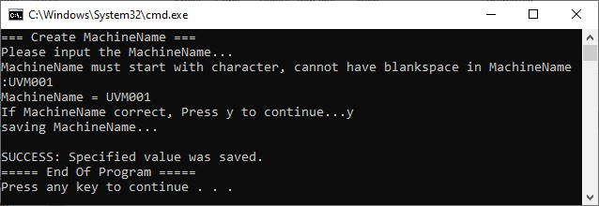

**[Note]** You still can change your Machine name in this Stage.

### **Troubleshooting**

1. This error will happen when batch no **Run as administrator**

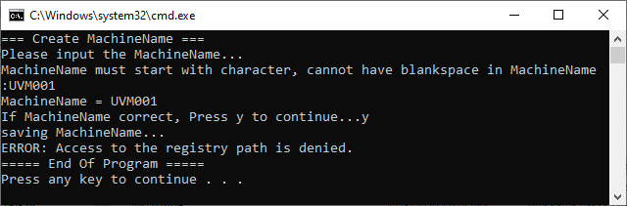

## Verify Machine Name Created

1. Open Folder “0 Deploy 20200518\01 Backup Program” folder
2. Select 02CheckMachineName.bat file, right click and select **Run as administrator**.
3. Ensure the machine name is correct. Done.

If not correct, please repeat Stage Create Machine Name.

**[Note]** You still can change your Machine name in this Stage.

### Troubleshooting

1. The saved Machine Name not found, will repeat Stage Create Machine Name

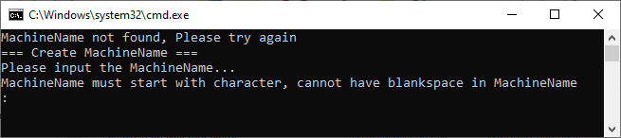

## Backup the program

**[Note] After** this Stage, you are **not** allowing change the Machine name.

1. Open Folder “0 Deploy 20200518\01 Backup Program” folder
2. Select 03Run.bat file, right click and select **Run as administrator**.
3. Ensure the Machine Name correct, Press y to continue.
4. Wait until program run complete.
5. From the program, it will print out the file was success backup
6. Done

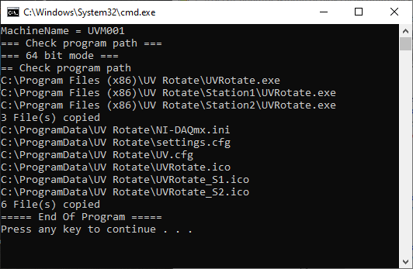

# Deploy the New Program

**[Note] After** this Stage, the program in Machine will overwrite.

1. Check the Machine Version

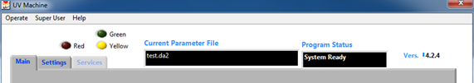

1. Open Folder “0 Deploy 20200518\ 02 Deploy Program\<Version>\ RecopyEXE” folder
   1. 4.0.0 = Cool Muscle Motor Driver
   2. 4.2.5 = Yamaha Motor Driver
   3. 4.4.1 = Yamaha Driver with Staging Feature
   4. 5.0.0 = Yamaha Driver for Up Down Design
2. Select 0Run.bat file, right click and select **Run as administrator**.
3. Done.

### **Troubleshooting**

1. This error will happen when batch no **Run as administrator**

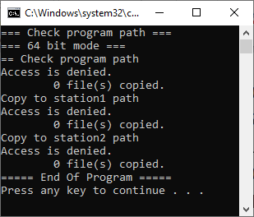

# Recover from Backup Program

1. Open Folder “0 Deploy 20200518\ 03 Recover Program” folder
2. Select 0Run.bat file, right click and select **Run as administrator**.
3. Wait until program run complete.
4. Done.